Test Questions Use the word bank below, and page 618-19 in your textbook, and label the
microscope parts and color each part a different color.
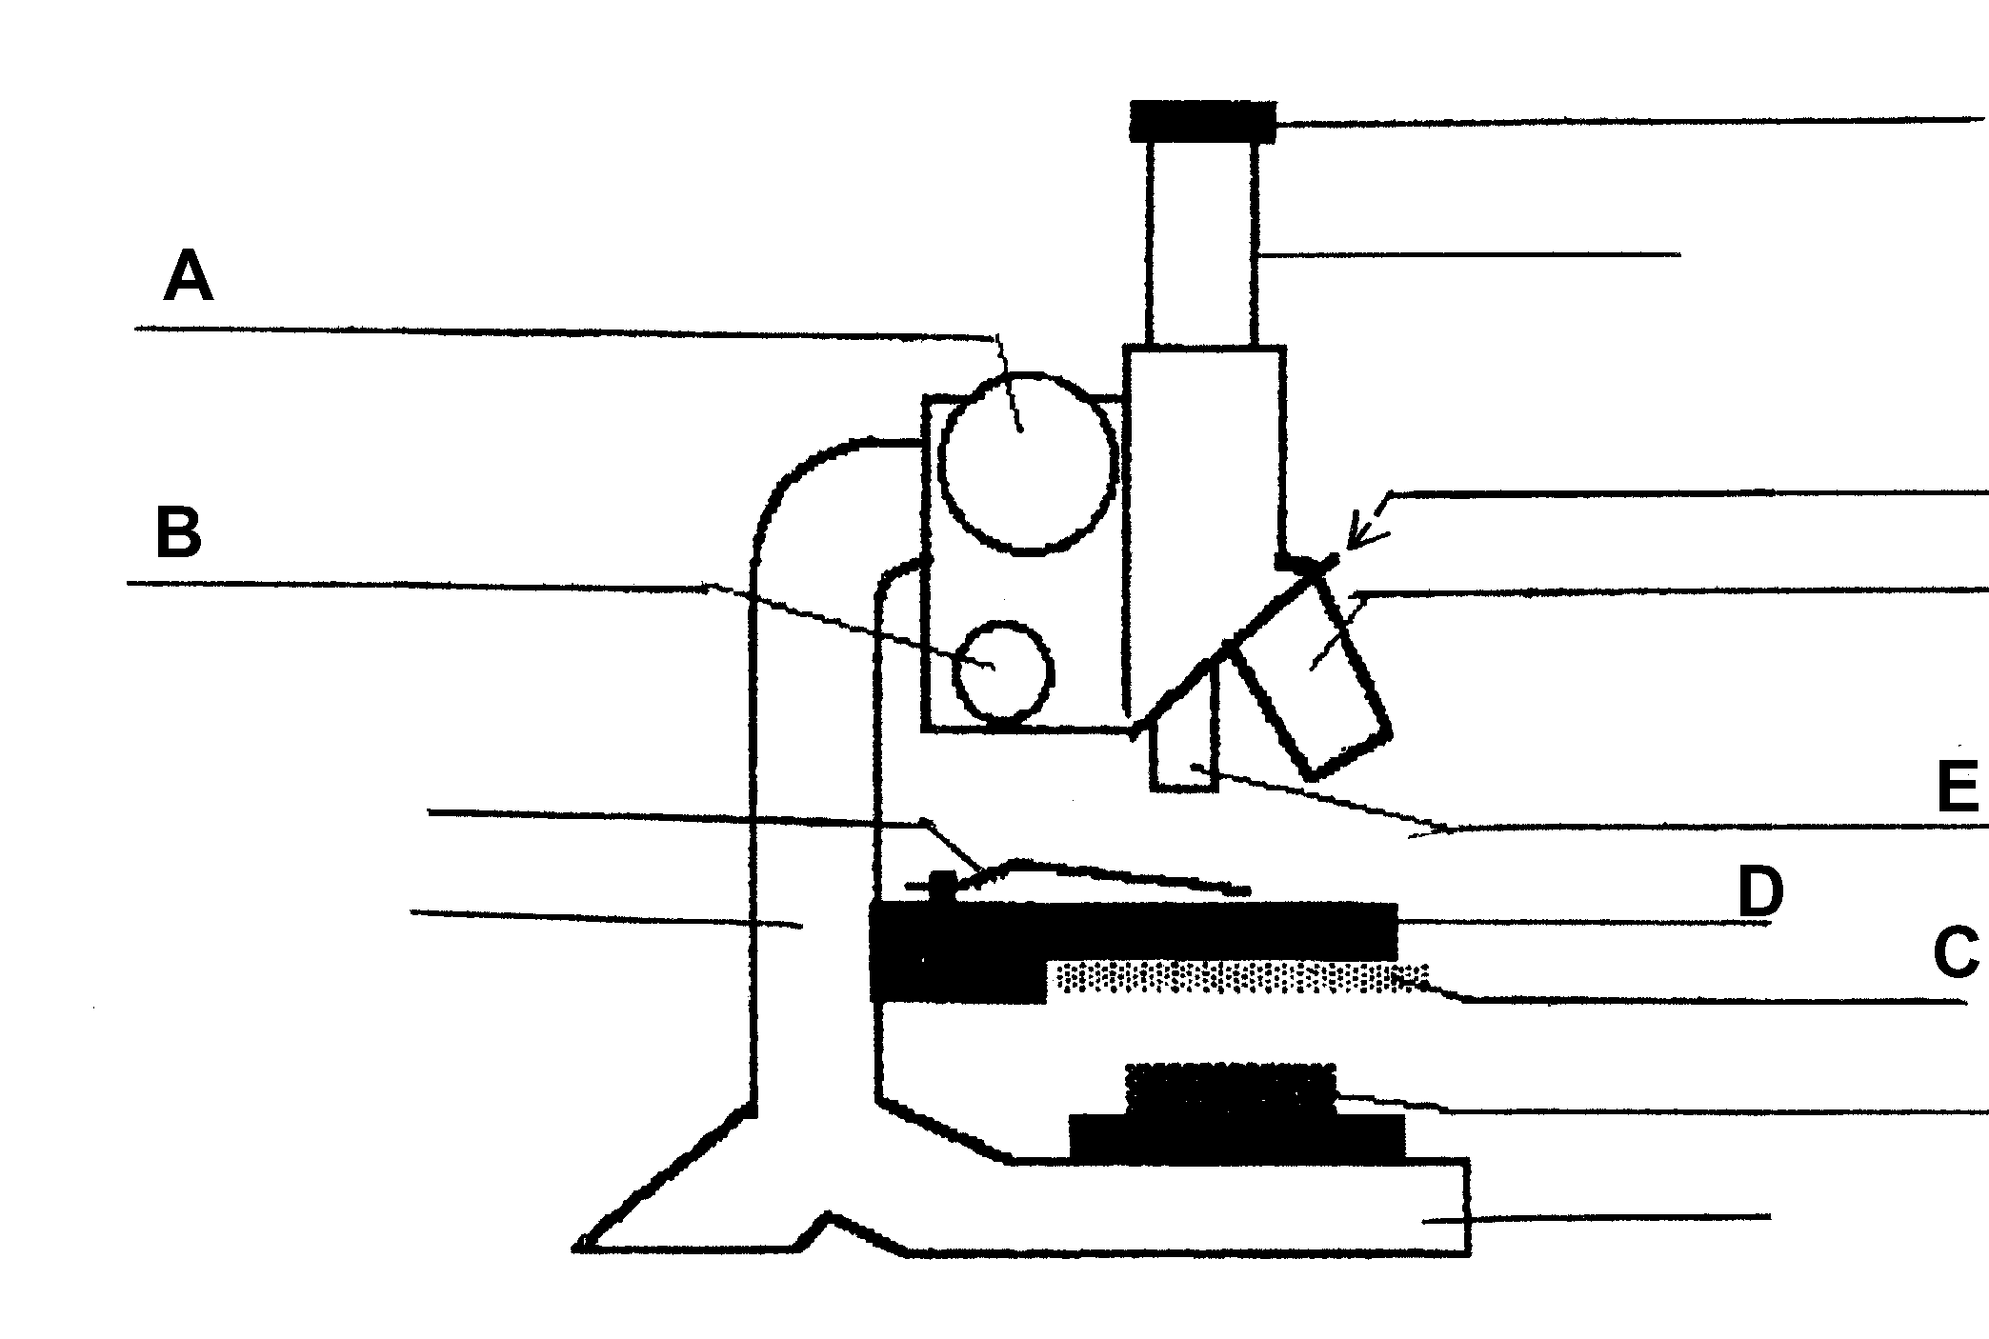
Nose piece
“Eye” Ocular lens
Body tube
Low power objective lens
High power objective lens
Stage
Light / mirror
base

Coarse adjustment knob
Fine adjustment knob
Arm
Stage clip

2. Where should the microscope be placed for use?
6. which knob should you use for focusing for medium or high power?
5.How do you focus with the low power objective?
4. Where should the stage be before starting to use the microscope?
1. What is the correct way to carry a microscope?
3. What should be used to clean the lenses?

- Always use two hands picking up or carrying a microscope. Place one hand under the base and one hand on the arm.
Your Hands Go
Here
- Place the microscope at least six (6) inches from the edge of the table — never on the edge of your workspace or on top of papers, books or other materials.
- When cleaning the lenses of a microscope, use lens paper. DO NOT touch the lenses with your fingers, water, or any other materials.
- Before starting to use the microscope, be sure the lowest power objective (smallest lens) is in place over the stage, and the stage is in its lowest position to mount the slide, then raise the stage with the coarse adjustment knob to the highest position.
7. What do you do when you have finished with the microscope?
- To focus the low power objective, use the coarse adjustment to bring the specimen into field of vision by lowering the stage until you see the specimen; then focus to make it as clear as possible.

Word Bank
Arm
Base
Coarse Adjustment Knob
Diaphragm
Fine Adjustment Knob
High Power Objective Lens
Light/Mirror
Low Power Objective Lens
Nose Piece
Ocular Lens
Stage
Stage Clips
Body Tube

e
- NEVER use the coarse adjustment knob (larger knob) to focus the high or middle power objectives (longest lenses). Use only the fine adjustment knob (smaller knob) for medium or high power.
- When finished:
  - Move the lowest power objective lens (smallest) into place over the stage.
  - Then lower the stage to its lowest position.
  - Remove the slide.
  - Turn off the light.
  - Wind up the cord loosely & use two hands to return (end of day).
  - Team cleans lab station and resets the lab tray.
6”

Summary

