HOW TO ACCESS THE ONLINE BOOK
Your online GoMath book contains many resources to help you with math! Take this quick tour of the online book and explore many more features on your own. You will need headphones to watch the video at the end.

- Go to my.hrw.com
- Use your Google account to log in. Find 8th grade book.
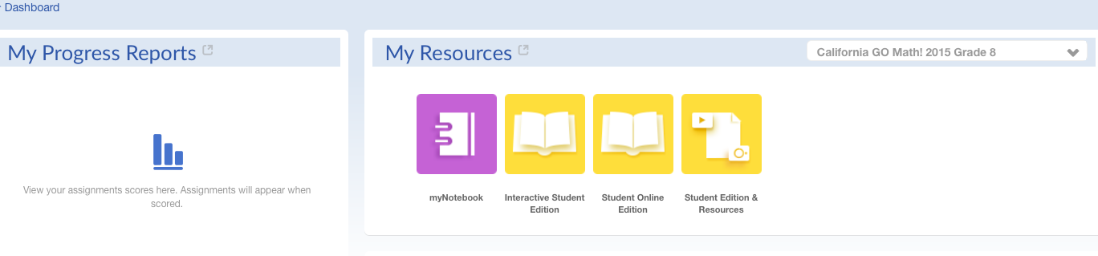
- Click on “Student Online Edition” (Yellow Icon)
- In the left column, click on “Contents” menu and choose “Unit 1 – Real Numbers, Exponents, and…”

- Then find “Module 1 Real Numbers.”

- Scroll down to find “Lesson 1.1 Rational and Irrational Numbers.”

- At the top of your screen,, find “Go to Page…” and type in 12. Hit return.

- In the left margin, click on “Resources” and then “Lesson-Level Resources.”

- Click on any of the “Personal Math Trainer” tabs and do the sample problems.

- To the right of the small screen, click on “Video Tutor” and watch the video.

- Explore any features of the online GoMath book that look interesting to you!
GO MATH 8 Scavenger Hunt

- Go to pg. 3. What are the 4 icons at the bottom of the page and what do they do?
- ____________________________________________________________________________________

- ____________________________________________________________________________________

- ____________________________________________________________________________________

- ____________________________________________________________________________________

- Go to pg. 6. What is the purpose of this page?

- Go to pg. 26. What does “H.O.T.” stand for?

- Go to pg. 27. If you’re having trouble answering questions, what can you find on this page to help you?

- Find the Unit 1 Study Guide.
- What pages is it found on?

- Why might this be useful?

- Go to pg. SA1. What is this? How can this be useful?

- Go to pg G2. What is this? How can this be useful?

