Gene of Interest | Resource Article
Insensitivity to Pain  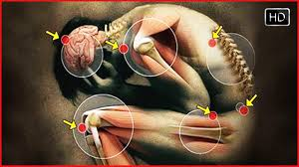 | https://www.independent.co.uk/life-style/health-and-families/health-news/the-people-who-cant-feel-pain-scientists-discover-cause-of-rare-inherited-condition-that-turns-off-10274604.html  http://www.dana.org/Cerebrum/2018/Alabama_to_Beijing_and_Back_The_Search_for_a_Pain_Gene/  http://blogs.plos.org/dnascience/2016/04/21/no-pain-and-extreme-pain-from-one-gene/  https://www.youtube.com/watch?v=Jw9a2wDgyd4&t=174s  https://www.youtube.com/watch?v=J12bqHo5xGU
Anti-Malaria Gene  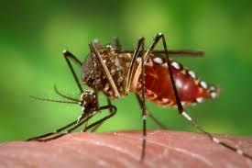 | https://www.nature.com/news/gene-drive-mosquitoes-engineered-to-fight-malaria-1.18858  https://www.npr.org/sections/health-shots/2016/12/14/504732533/to-fight-malaria-scientists-try-genetic-engineering-to-wipe-out-mosquitoes  https://www.theguardian.com/science/2015/nov/23/anti-malarial-mosquitoes-created-using-controversial-genetic-technology  https://news.nationalgeographic.com/news/2001/11/1114_TVmalariagene_2.html
Glow Gene  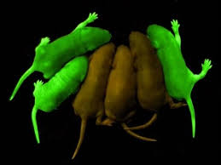 | https://blogs.scientificamerican.com/observations/jellyfish-genes-make-glow-in-the-dark-cats/  https://www.conncoll.edu/ccacad/zimmer/GFP-ww/GFP-1.htm  http://newsfeed.time.com/2013/12/30/scientists-create-glow-in-the-dark-pigs-just-in-time-for-your-next-rave/  https://www.treehugger.com/animals/glow-dark-chickens-are-genetically-engineered-fight-bird-flu.html
Bone Strengthening | http://www.biotechdaily.com/genomics- proteomics/articles/58450000/genetic- mutation-causes-high-bone-density.ht ml  http://www.nejm.org/doi/full/10.1056/NEJMoa013444
Organ Compatibility  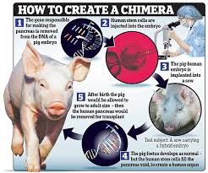 | http://www.genomecompiler.com/genetically-engineered-organs/  https://www.nature.com/articles/3302020
Antibiotic Sensitivity Gene | https://www.nature.com/articles/ncomms6792
Muscle Increase Gene | https://ca.pbslearningmedia.org/resource/tdc02.sci.life.gen.salmon/super-salmon/#.WsJaitPwaMI  https://www.scientificamerican.com/article/muscles-genes-cheats-2012-olympics-london/  http://www.nbcnews.com/id/4282866/ns/health-genetics/t/gene-therapy-creates-super-muscles/  https://www.medicalnewstoday.com/articles/318412.php
Cancer Deactivator Gene  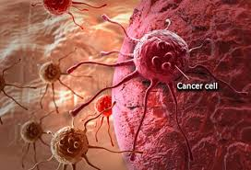 | https://www.independent.co.uk/news/science/gene-editing-crispr-cure-cancer-inherited-diseases-flawed-mutations-side-effects-a7761666.html  https://www.technologyreview.com/s/609999/us-doctors-plan-to-treat-cancer-patients-using-crispr/  https://www.popularmechanics.com/science/health/news/a18099/gene-editing-eliminate-cancer/  http://www.businessinsider.com/cellectis-ceo-andre-choulika-on-gene-editing-talens-2016-1  https://www.webmd.com/cancer/news/20070509/turn-on-gene-turn-off-cancer  https://www.livescience.com/52432-elephants-cancer-resistance.html  http://www.latimes.com/science/sciencenow/la-sci-sn-car-t-cancer-drug-20170830-htmlstory.html
Drought/Disease Resistance Gene | https://www.nature.com/scitable/blog/plantchemcast/defying_drought_through_genetic_engineering  https://plantscientist.wordpress.com/2015/02/03/the-promise-of-drought-tolerant-and-disease-resistant-barley/
Silk Production Gene | http://blogs.discovermagazine.com/notrocketscience/2012/01/03/genetically-engineered-silkworms-with-spider-genes-spin-super-strong-silk/#.Wr5xvtPwbSw  http://www.sciencemag.org/news/2017/10/spinning-spider-silk-startup-gold
Anti-Aging Gene | https://www.sciencealert.com/amish-community-rare-genetic-mutation-protects-against-ageing-serpine1  https://futurism.com/scientists-found-first-anti-aging-genetic-mutation/  https://health.howstuffworks.com/wellness/aging/anti-aging-tips/anti-aging-gene1.htm  https://www.scientificamerican.com/article/aging-is-reversible-at-least-in-human-cells-and-live-mice/
Regeneration Gene 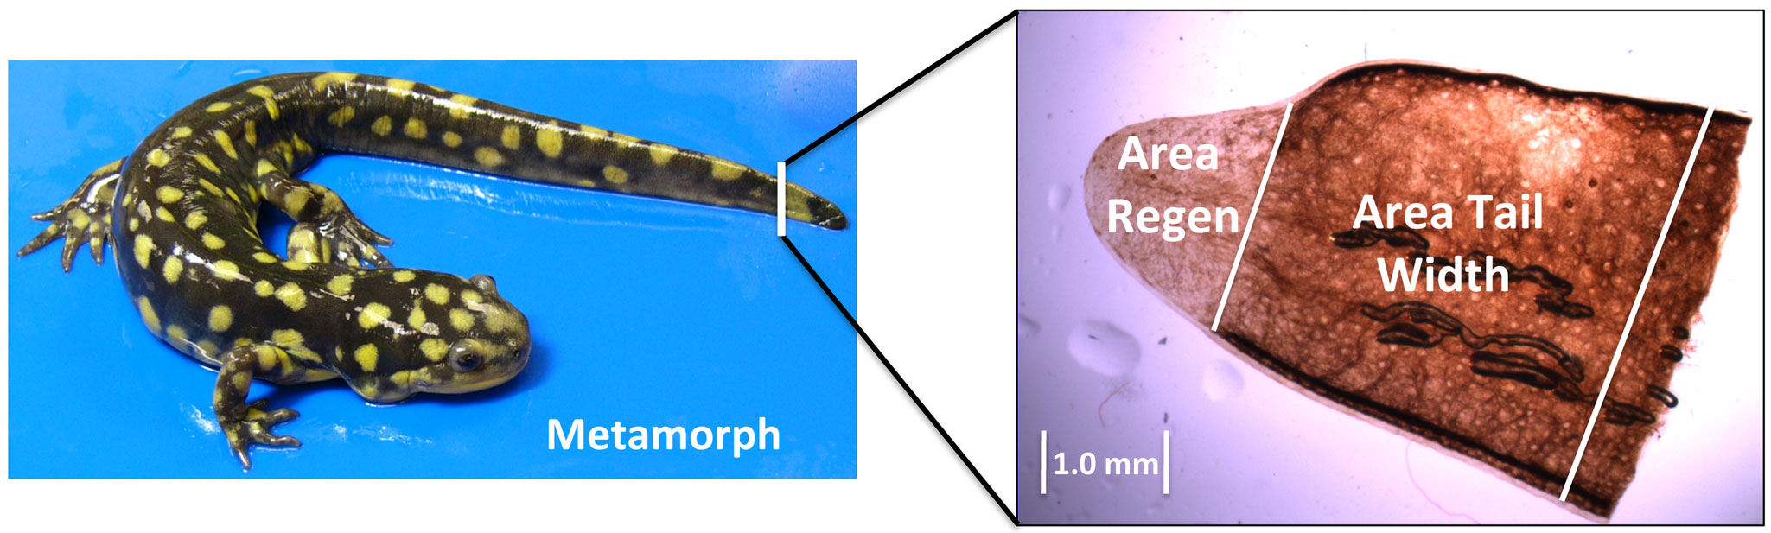 | https://www.popsci.com/science/article/2010-03/humans-could-regenerate-tissue-newts-switchin-single-gene  https://www.sciencedaily.com/releases/2016/04/160406140405.htm  https://humanlimbregeneration.com/human-limb-regrowth-with-acorn-worm-dna

