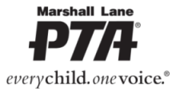
ROLLING HILLS MIDDLE SCHOOL

DONATION DRIVE FUNDRAISER

Earn $1250 for our kids!!!!
Fill a GOODWILL truck with Electronic-waste and more!

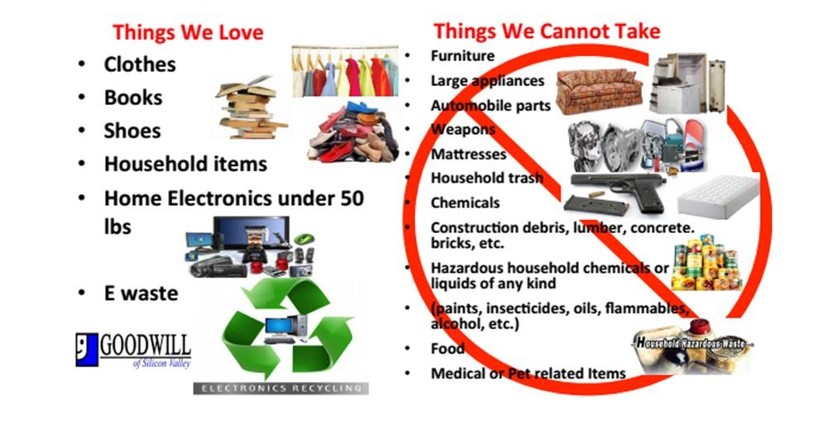
SUNDAY, JANUARY 31ST, 10AM – 4PM

