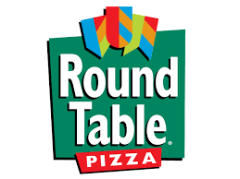
FUNDRAISING NEVER TASTED SO GOOD!

Round Table Pizza “Giving Back Fundraising Program” for local organizations welcomes the participation of friends, family and supporters of:

WHO: ROLLING HILLS MIDDLE SCHOOL

WHEN: TUESDAY, MARCH 16th
AND
WEDNESDAY, MARCH 17th

WHERE: ROUND TABLE PIZZA
1472 POLLARD ROAD
LOS GATOS

Upon presentation of this flyer to the cashier on the above dates and location only, Round Table Pizza will donate 15% of your Take-Out or Dine-In food and beverage purchases to Rolling Hills Middle School all day – LUNCH AND DINNER. Flyer must be presented for RHMS to receive the 15%!

Not valid with other Round Table Pizza promotions or discounts. Valid only at our Pollard Road location.

PLEASE DO NOT SOLICIT OTHER GUESTS ON THE PREMISES.

