This activity is designed to help you manage some keys on a scientific calculator. The calculator used is the TI-30X IIS (below). If you use your own calculator, some of the keys may look different
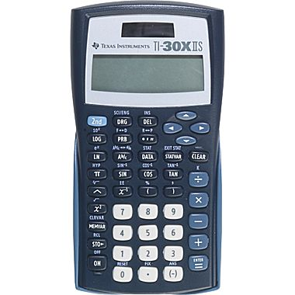
INSRUCTIONS: Evaluate each expression and write the answer on the line provided.

1.) ${28}^{2}$

____________
2.) ${12}^{3}$

____________
3.) $\sqrt{1024}$

____________
4.) $\sqrt[3]{1331}$

____________
5.) $\frac{\sqrt{17}}{6}$

____________
6.) $\frac{\sqrt{17}}{6}$

____________
7.) $6^{4}$

____________
8.) $4π$

_____________
9.) $4π$

____________
10.) $\frac{1}{5}$

____________
11.) $3\frac{4}{5}$

____________
12) $-3^{2}$

____________
13.) $(-3^{2})$

____________
14.) ${25}^{13}$

____________
15.) $\frac{2}{{35}^{14}}$

____________
16.) $-2.5-\left(0.2-6\right)+4.3$

___________
17.) $-2.5+\left(-0.2+6\right)+4.3$

____________
18.) $3-2(4-6)$

____________

