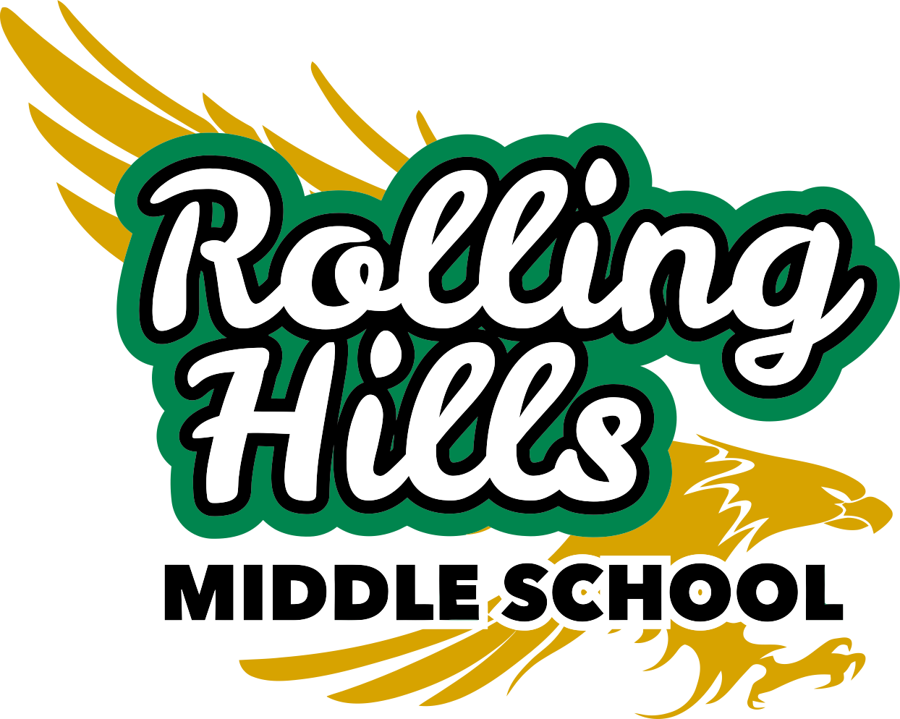
Back-To-School Night Schedule
September 9, 2015
PERIOD (Time) | Room Number | Class | Teacher
6:00 – 6:10 | Cafeteria | 6th Grade Science Camp Meeting | 6th Grade Only!!!!
1 6:15 - 6:30
2 6:35 - 6:45
3 6:50 - 7:00
4 7:05 - 7:15
5 7:20 - 7:30
6 7:35 - 7:45
7:50- 8:00 | Cafeteria | 8th Grade Promotion Meeting | 8th Grade Only!!!!!!

Support our kids - Remember to visit the PTA Table
to complete your Direct Donation & your PTA Membership form
Public Funding is not sufficient to support the many great educational programs and activities at Rolling Hills Middle School. Without PTA funding many of our valuable programs that we have come to expect and benefit from would not exist.

The goal of RHMS PTA is to raise $50,000 in Direct Donations this year. This contributes to more than half of our total funding. Suggested donation is $125 per student, but please give what you can.

What can you do?

✔ Become a PTA member
✔ Participate in Direct Donation
✔ Sign up for “free money” by Giving without Paying – eScrip,
Amazon, etc.
✔ Volunteer where you can
✔ Attend PTA Meetings. First PTA meeting this year is 9/16.



