Ready Position

“ SAY IT”
“ DO IT”

LEGS & FEET
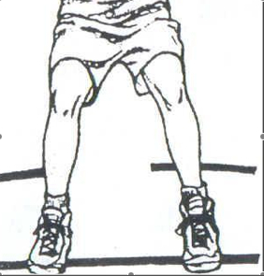
Feet shoulder width apart

Knees slightly bent

Weight on the ball of the foot

Dominate foot slightly in front of the other

“ DO IT”
“ SAY IT”
ARMS, TORSO & EYES

Arms out in front and away from body
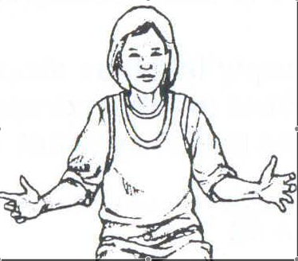
Back straight

Eyes looking forward

